**Problem 1**

A Cat, a Parrot, and a Bag of Seed:

A man finds himself on a riverbank with a cat, a parrot and a bag of seed. He needs to transport all three to the other side of the river in his boat. However, the boat has room for only the man himself and one other item (either the cat, parrot or seed). In his absence, the cat could eat the parrot, and the parrot would eat the bag of seed. Show how he can get all the passengers to the other side, without leaving the wrong ones alone together.

**Defining the problem:**

The problem is that the cat, the parrot and the bag of seed cannot be left by themselves unsupervised, in order to ensure the cat does not eat the parrot and the parrot does not eat the bag of seed. The word problem does not state how many trips the man is allowed to take back and forth across the river. The main goal is to get the cat, the parrot and the bag of seed to the other side of the river.

**Breaking the problem apart:**

The man must get the cat, the parrot and the bag of seed to the other side of the river, without leaving the cat alone with the parrot or the parrot alone with the bag of seed. The man can only carry one item to the other side in his boat per trip. The constraints are that if he leaves the cat alone with the parrot, the cat will eat the parrot, if he leaves the bag of seed with the parrot, the parrot will eat the bag of seed. The sub-goals are to get the cat across the river, get the parrot across the river and to get the bag of seed across the river.

**Identifying potential solutions:**

One potential solution could be to take the parrot over first, come back and get the cat, take the cat over and then bring the parrot back across the river and take the bag of seed over to the cat then come back across and get the parrot and take the parrot over consisting of 7 trips back and forth.

Another solution could be to take the parrot over first, then come back for the bag of seed. Take the bag of seed over and bring the parrot back, the take the cat over to the other side, and finally come back to take the parrot over also consisting of 7 trips back and forth.

**Evaluating the potential solutions:**

Both solutions meet the goals of transporting all items across the river one at a time so that the cat is not left alone with the parrot and the parrot is not left alone with the bag of seed. Both solutions work for all cases because the cat is never alone with the parrot and the parrot is never alone with the bag of seed.

**Choosing a solution and developing a plan to implement it:**

The man should first load the parrot into the boat and transport it across the river leaving behind the cat and the bag of seed. Once across the river the man should unload the parrot and continue his trip back across the river. The man should then load the cat and transport the cat across the river. Once at the other side the man should unload the cat off the boat and load the parrot back onto the boat and transport the parrot back to its original location leaving the cat behind. Once back to his original location the man should unload the parrot off the boat and load the bag of seed onto to the boat and continue across the river. Once he is at his destination the man should unload the bag seed leaving it behind with the cat and continue alone to his original location. Once back at the man’s original location he should load the parrot and transport the parrot to the other side of the river.

**Problem 2**

Socks in the Dark:

There are 20 socks in a drawer: 5 pairs of black socks, 3 pairs of brown and 2 pairs of white. You select the socks in the dark and can check them only after a selection has been made. What is the smallest number of socks you need to select to guarantee getting the following?

a) At least one matching pair  
b) At least one matching pair *of each color.*

**Defining the problem:**

The problem is that you need to select a matching pairs of socks with no light and limited visibility. You have 3 different colors of socks and a different quantity of each color. The word problem does not state a limit of how many socks you can select at a time but it does state that you need to select the minimum number of socks can only check the socks after a selection has been made, so you can only select a section of socks at once to see if the problem has been solved. The goal of is to grab the smallest number of socks but ensure you end up with at least one matching pair and at least one matching pair for each color.

**Breaking the problem apart:**

I have three different colors of socks, and 20 socks total. 10 are black (5 pairs), 6 are brown (3 pairs), and 4 are white (2 pairs). I need to pick the minimum number of socks to get one matching pair, and then I need to pick the minimum number of socks to get one matching pair per color (3 pairs). The constraints are that I cannot check my selection until after my selection has been made, and there is no light.

I**dentifying potential solutions:**

To get one matching pair you would only have to grab 4 socks 3 maybe different colors but the fourth will match at least one of the colors. If it takes 4 socks to match at least one pair of socks, I could multiply 4 by the number of colors to get 3 matching pairs of socks (4*3=12) so 12 socks could be picked to match all three colors. This may work but maybe not for all cases. If I look inside the drawer with the light on I can choose 4 socks and out of the 20 and get a single match every time but if I choose 12 socks I am able to choose 12 socks that will only match pairs in 2 colors.

Pulling out 4 socks will get me at least on matching pair of socks every time, pulling out 18 socks will get me a matching pair of socks in each color every time

**Evaluating the potential solutions:**

The first solutions works for part a of the problem selecting 4 socks will get a match every time because no matter how many possibilities it is impossible to select 4 socks out of the drawer and not have at least one match

Part b of the problem if I select 12 socks from the drawer each time I have a high probability of getting at least one matching pair of socks in each color but there is still a probability that I could choose 12 socks and only be able to match a pair of socks in only 2 colors. The only definitive way to choose a matching pair of socks in each color every time, without a possibility of ending up with only 2 matches is to choose 18 socks.

**Choosing a solutions and developing a plan to implement it:**

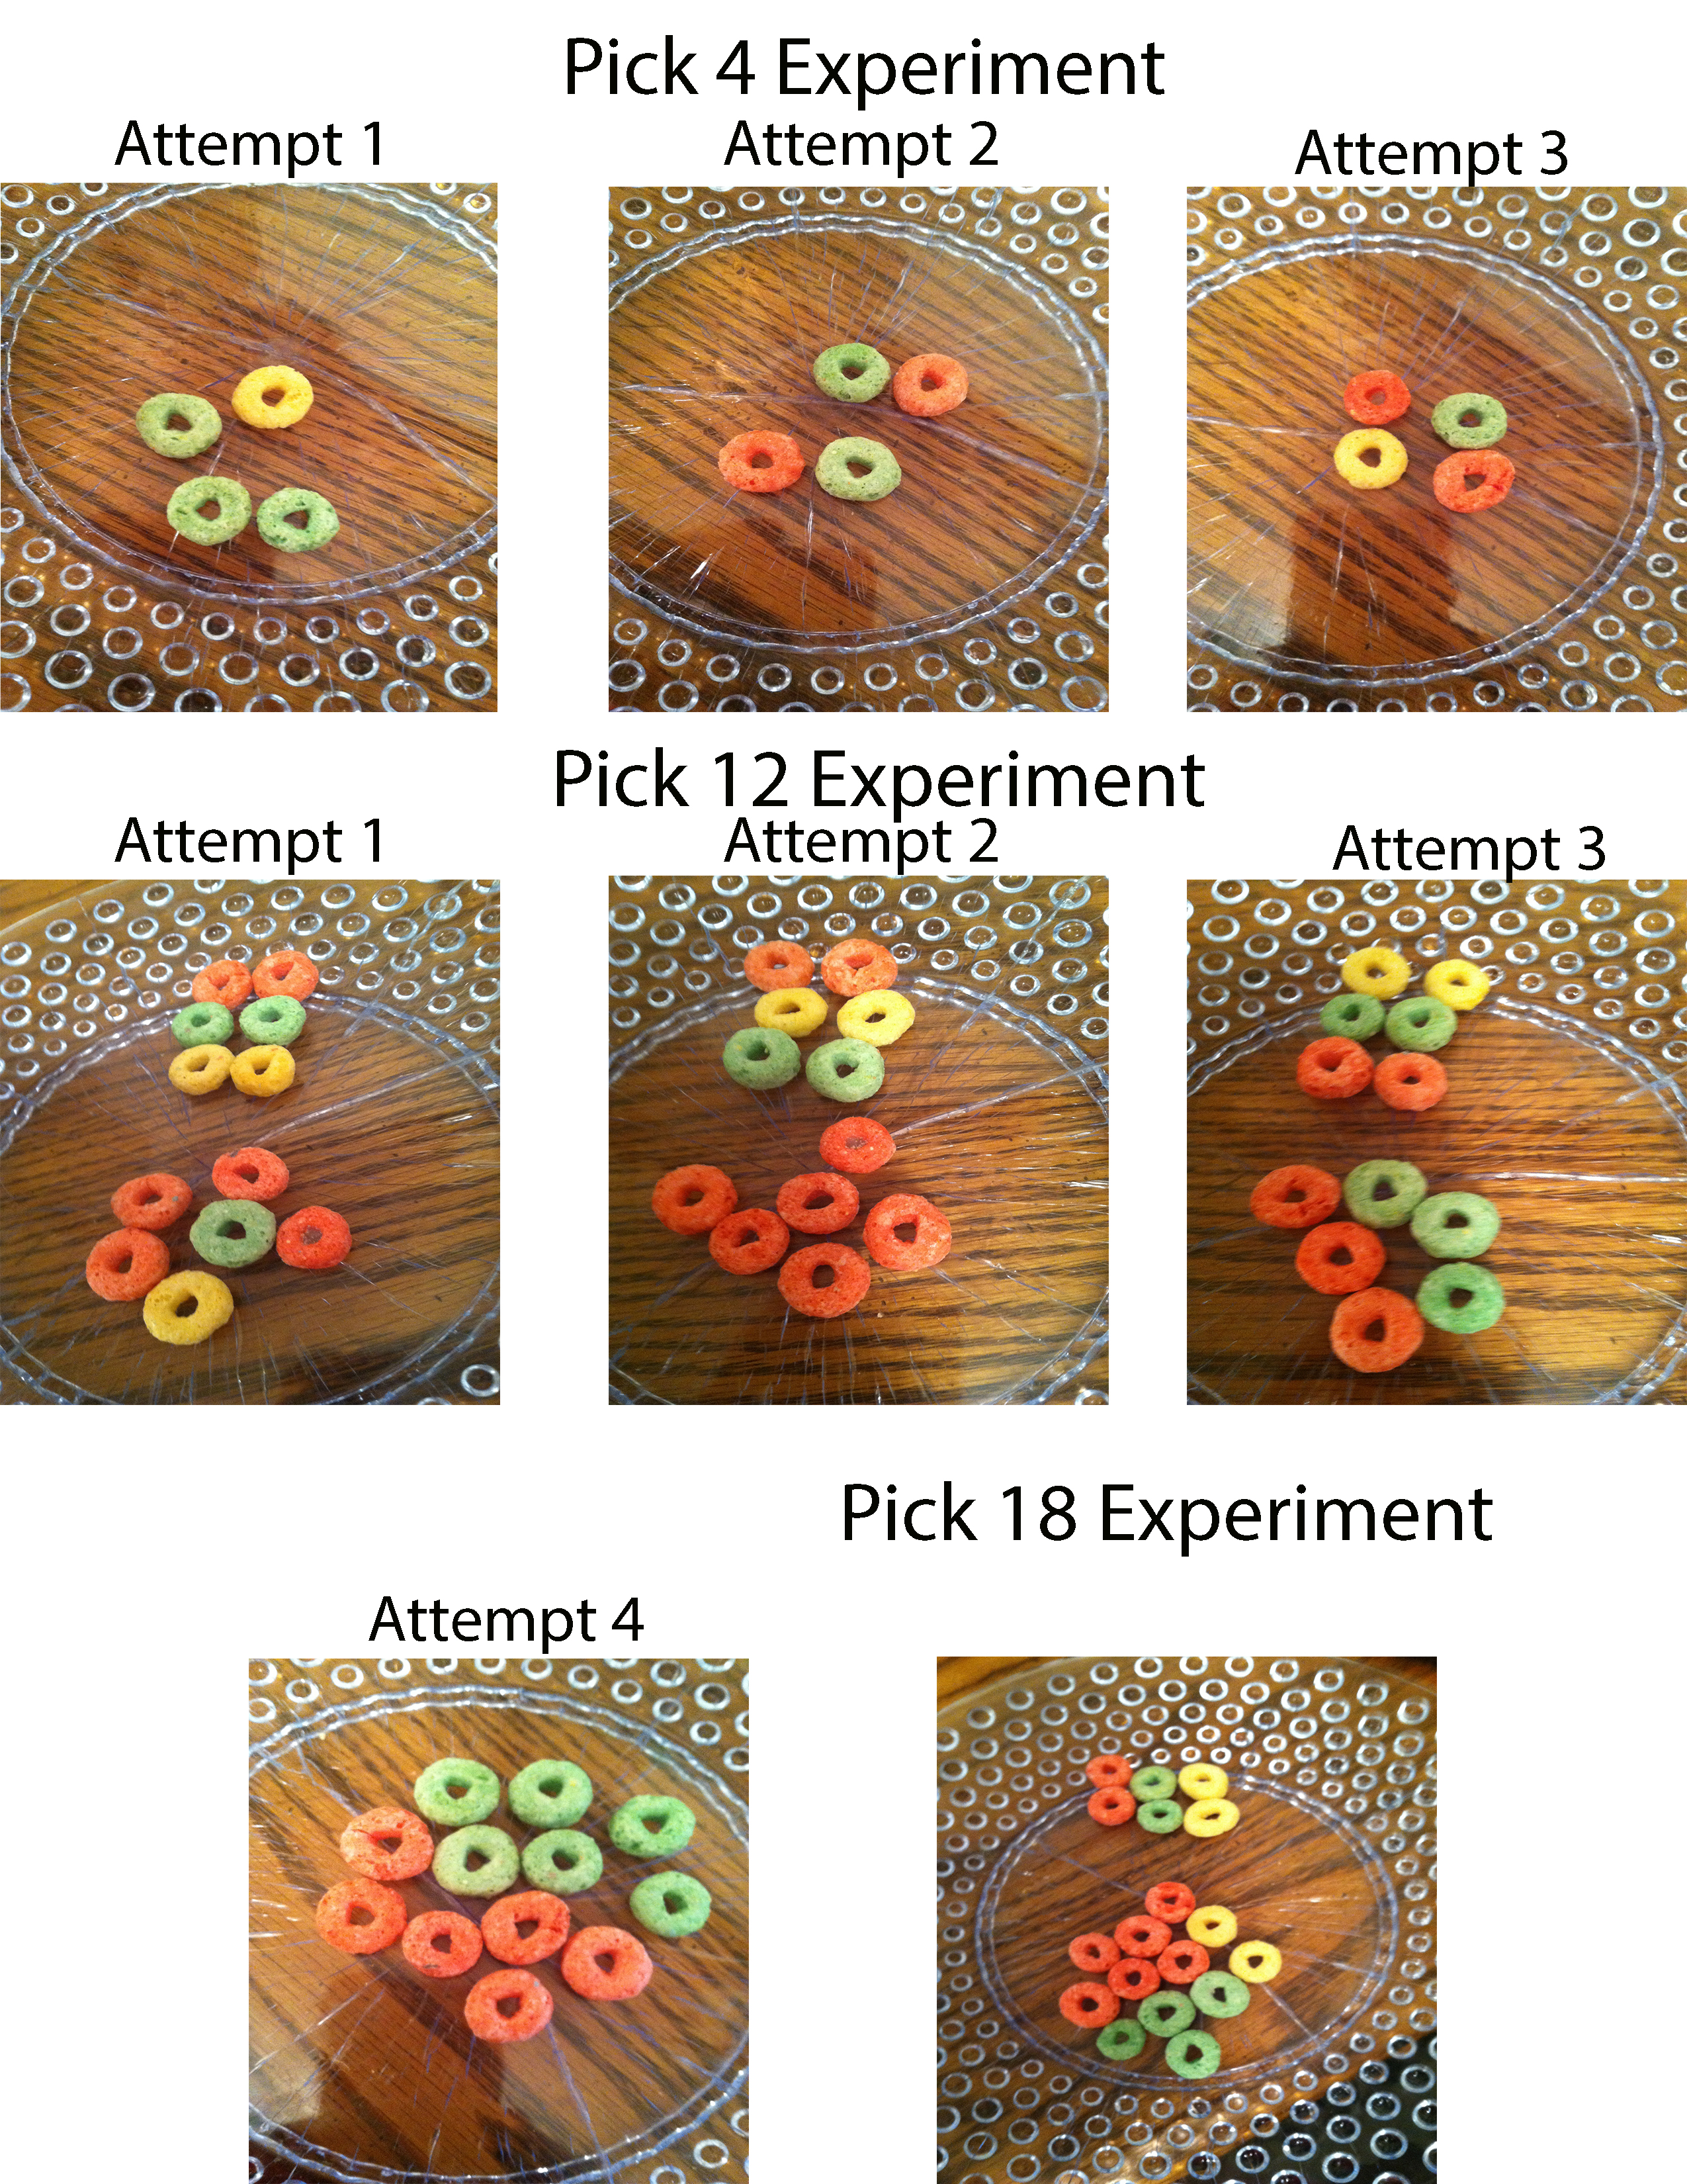 The solution is to go to the drawer and select 4 socks in order to get at least one matching pair, and select 18 socks in order to get at least one matching pair in each color. I tested this solution using a bowl filled with 20 fruit loops, 10 red, 6 green, and 4 yellow. While looking I can pull out one of each color, red, green and yellow. No matter which color I chose next will give me a matching pair in a single color. Using this same technique I can choose up to 17 fruit loops without getting a matching pair in all three colors. However when I choose 18 I have a single match in every color. Every time I chose 4, I was able to get at least one matching color every time. When I chose 12, was able to get a match 3 out of 4 times, but the problem states that we need to ensure a match of each color. To solve the problem so that I would get a match of each color every time I would have to choose 18.

**Problem 3**

Predicting Fingers:

A little girl counts using the fingers of her left hand as follows: She starts by calling her thumb 1, the first finger 2, middle finder 3, ring finger 4, and little finger 5. Then she reverses direction, calling the ring finger 6, middle finger 7, first finger 8 and thumb 9, after which she calls her first finger 10 and so on. If she continues to count in this manner, on which finger will she stop?

a) What if the girl counts from 1 to 10?

b) What if the girl counts from 1 to 100?

c) What if the girl counts from 1 to 1000?

**Defining the problem:**

The problem is that when the little girl counts starting from her thumb moving back and forth when she gets to 10 she stops on her pointer finger, when she counts to 20 she will land on her ring finger. So every time she counts up ten more she lands on a different finger. I need to determine what finger she will land on when she gets to 10, 100, and 1000.

**Breaking the problem apart:**

I need to determine what finger the girl will land on when she counts to 10 starting from her thumb moving forward and backward. I then need to determine what finger the girl will land on as she gets to 100 and finally, I need to determine what finger she will land on when she reaches 1000. The sub goals are to find the finger she will land on when she reaches 10, find the finger she will land on when she reaches 20 and 30 and so on. Find the common pattern to determine what finger she will land on as she hits 100 and 1000. There doesn’t seem to be any constraints with this problem.

**Identifying potential solutions:**

One solution to this problem would be to count on your left hand in the same manner that the girl does and keep track of what finger you land on every time you reach 10, 20, 30 and so on and mark down what finger you land on when you reach 10, 100, and 1000. This would be time consuming and could get confusing after a while

Another solution would be to count in the same manner until you recognize a pattern, then you can create a chart that shows the fingers that she would land on for every ten counts. Use the chart to find out where she would land when she reaches 10, 100 and 1000.

**Evaluating the potential solutions:**

The first solution meets all of the goals and would work in every case but could be confusing and time consuming to reach the final answers to the problem. The second solution would be faster more efficient it would also show a pattern and back up the answers to the problem.

**Choosing a solution and developing a plan to implement it:**

|  |  |  |  |
| --- | --- | --- | --- |
| Pointer Finger | Ring Finger | Ring Finger | Pointer Finger |
| 10 | 20 | 30 | 40 |
| 50 | 60 | 70 | 80 |
| 90 | 100 | 110 | 120 |
| 130 | 140 | 150 | 160 |
| 170 | 180 | 190 | 200 |
| 210 | 220 | 230 | 240 |
| 250 | 260 | 270 | 280 |
| 290 | 300 | 310 | 320 |
| 330 | 340 | 350 | 360 |
| 370 | 380 | 390 | 400 |
| 410 | 420 | 430 | 440 |
| 450 | 460 | 470 | 480 |
| 490 | 500 | 510 | 520 |
| 530 | 540 | 550 | 560 |
| 570 | 580 | 590 | 600 |
| 610 | 620 | 630 | 640 |
| 650 | 660 | 670 | 680 |
| 690 | 700 | 710 | 720 |
| 730 | 740 | 750 | 760 |
| 770 | 780 | 790 | 800 |
| 810 | 820 | 830 | 840 |
| 850 | 860 | 870 | 880 |
| 890 | 900 | 910 | 920 |
| 930 | 940 | 950 | 960 |
| 970 | 980 | 990 | 1000 |

First start counting to 50 on your left hand starting with your thumb as 1 pointer finger 2 middle finger 3, ring finger 4, pinky 5, ring finger 6, middle finger 7, pointer finger 8 thumb 9 and so on. Find the pattern that shows that every 10 counts lands on either the pointer finger or the ring finger. We can now develop out chart that will show that when she gets to 10 she will land on her pointer finger, when she counts to 100 she will land on her ring finger and when she counts to 1000 she will land on her pointer finger.